Calibration Protocols

Force measurement protocol
For every inclination of the braking ramp that you investigate, follow the next steps:

Step 1: Place your cart in the middle of the second ramp. Use the push bar of the spring scale to hold the cart in the same position. Move the cart upwards very slightly (less than half an inch), and let it fall back on the spring scale. Record the force measurement indicated by the spring scale. Repeat this step a few more times, until you do not see a difference larger than 0.2 N between your measurements. Record the force measurement indicated by the spring scale.

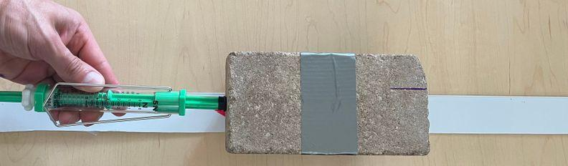

Step 2: Measure the force on the cart by placing the cart on the second ramp and holding it in the same position using the spring scale hook. Push the cart upwards very slightly (less than half an inch), and let it move downwards away from the spring scale. Repeat this step a few more times, until you do not see a difference larger than 0.2 N between your measurements. Record the force measurement indicated by the spring scale.

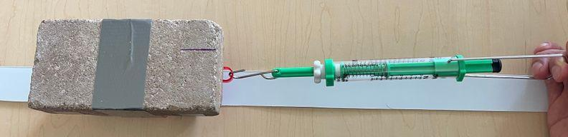

Step 3: Average all your force measurements, and use this value for the next part of the analysis.

Cart release protocol
Step 1: Find the marks on the middle of the cart on both sides. These will be your reference marks to ensure your cart is always released from the same position. | 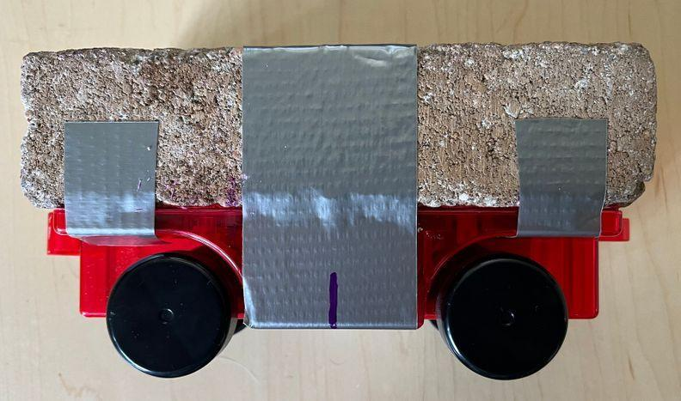
Step 2: Place the cart on the launching site by aligning the reference marks with the starting line. | 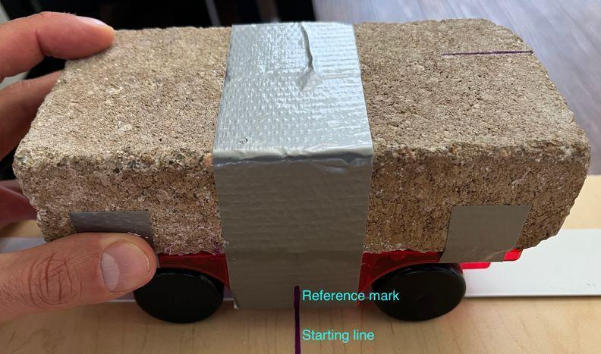
Step 3: Indicate to your teammates that you will be about to release the cart, so they can get ready to measure the time.

Time Measurement Protocol
Step 1: Have one person get ready to release the cart from the starting line on the first ramp. This person should say “ready” to signal the other members of the group that the cart is about to be released so they can get ready to measure the time.
Step 2: The person measuring the time should start the timer when the middle of the cart (represented by the reference marks on the tape) passes through the intersection of the two ramps and stop it when it reaches the furthest distance on the second ramp. This corresponds to when the cart’s velocity reaches 0 m/2 for a brief moment.
Step 3: Repeat this test as many times as necessary, recording the time you obtain from each trial until your group considers that the measurements are relatively consistent.

Data Analysis Protocol
- Use https://codap.concord.org/app/static/dg/en/cert/index.html to identify outliers in your data
- Watch https://www.youtube.com/watch?v=XWL4hif9iHI&list=PLSLDxqPb5NQmc9aOPrh0SjG_BRiZsVdWA&index=7 for a short tutorial for how to identify outliers using CODAP
We know that it is not possible to completely eliminate error from our measurements. Fortunately, CODAP provides us with a visual summary of our data that will help us quickly identify how our data is distributed and whether there are values that need to be removed (outliers).

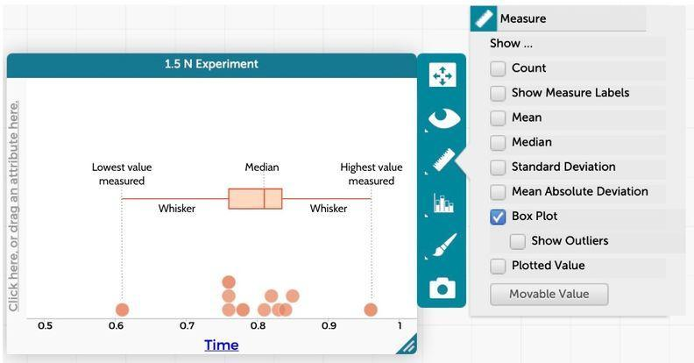
The Box Plot option will help us visualize the following characteristics of your data:
The shape of the box: The rectangular shape of the box tells us where half of our results are distributed. The wider the box, the more variation in your data. Values that are too low or too large increase the variation in your data.
The whiskers: These lines show where the other half of your data is distributed. The longer the whiskers, the more variation in your data.
The median: This value shows us the midpoint of your results. If the median is closer to the left, it suggests your results are closer to the lowest time you recorded. In the image above, the median is slightly closer to the right of the box, suggesting our measurements are closer to the highest value we recorded. When you click on the “Show Outliers” option, it will show you the values that are too different compared to the rest of your results, and are being automatically left out of the calculation of the median.
Once you have rendered your data in this way in CODAP record the median value as your Δt for each ramp elevation you tested.

